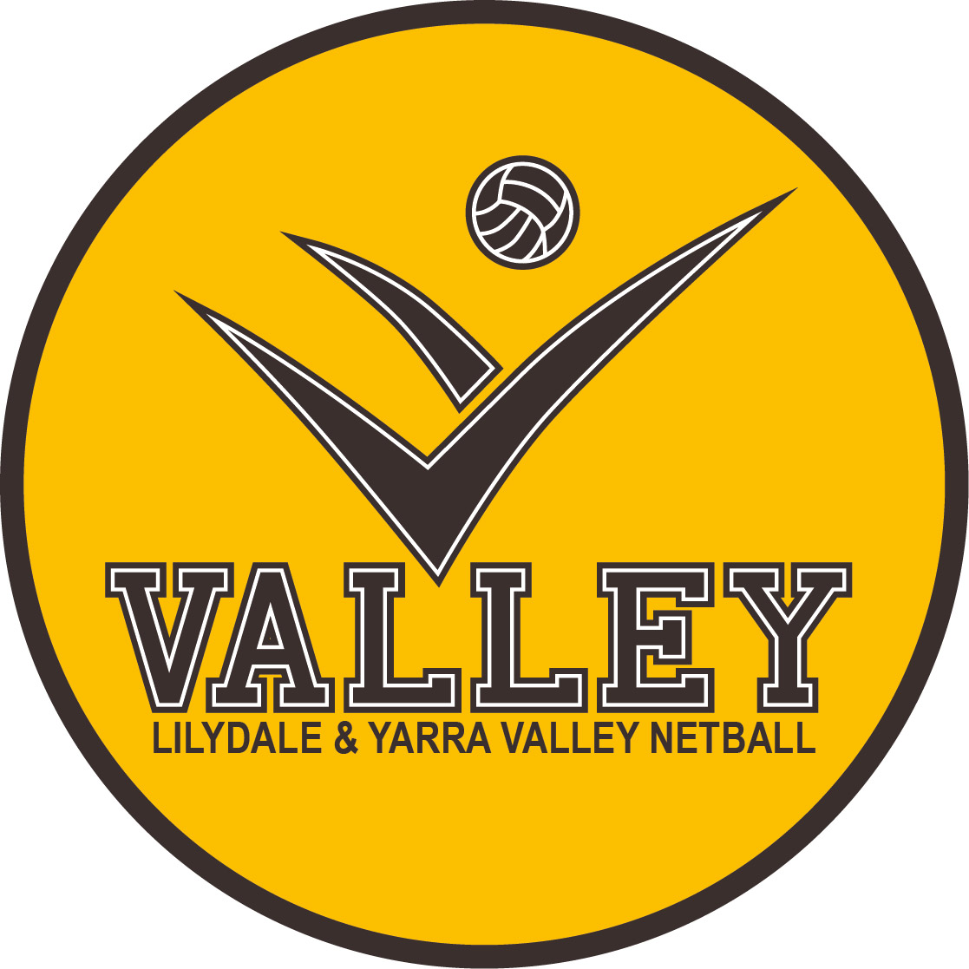COVID SAFE PLAN

COVID SAFE PRINCIPLES:

1. Ensure social distancing
2. Wear a face mask.
3. Practice good hygiene
4. Keep records and act quickly if participants, volunteers, or organisers become unwell
5. Avoid interactions in enclosed spaces.
6. Create workforce/activity bubbles.

Organisation: Lilydale and Yarra Valley Netball Association
ABN: 18493397085
Contact Name: Simon Grimes
Mobile: 0434 434 117
Email: president@lyvna.com.au
Physical Address: Pinks Reserve, 123B Liverpool Road, Kilsyth Vic 3137
Date Completed or Reviewed: 23/10/2021

1. ENSURE PHYSICAL DISTANCING.

- Modifying sporting activities to ensure participants remain 1.5metres apart where possible except when engaging in physical activity.
- Designated areas for court entrance and exits.
- Designated spectator areas for numbered courts.
- Staggering of game times, allowing fifteen minutes between games.
- Using floor markings to maintain distance at outside drinks canteen.
- Display of poster physical distancing information.
- 16 years+ staff, administrators, coaches, umpires, supervisors, mentors, etc. must be fully vaccinated and provide proof of vaccination status to enter the venue.
- Exceptions apply to those with a medical exemption.

2. WEARING A FACE MASK.
- Everyone, 12 years and over, must carry a face mask.
- A face mask must be worn indoors and outdoors unless an exemption applies.
- Participants do not need to wear a face mask while training.
- Face masks must be worn when not actively participating.
- Updated public health advice on masks is available at: https://www.dhhs.vic.gov.au/face-masks-vic-covid-19

3. PRACTICE GOOD HYGIENE AND IMPLEMENT THOROUGH CLEANING PROTOCOLS.
- Clean frequently touched surfaces i.e., door handles in high traffic areas, toilet basins, taps, toilet roll holders, push buttons of toilets with appropriate cleaning products, including detergent and disinfectant.
- Roster of timed cleaning for frequently touched areas and signed off by staff. This will occur between netball games time slots.
- Training of how to clean given to staff. Use of paper towel and disposable disinfectant wipes where possible. If cloths used, they are cleaned (soaked 10mins in disinfectant) between cleans. A deep clean performed by employed contractor prior to next use of the facility.
- Home team to pick up score sheet from window. Home team scorer uses their own pen to score. Umpires and Scorers to sign score sheet. No need for captains of team to sign. Umpire to return score sheet to window. Score boards will be cleaned after each game.
- Sharing of equipment should be kept to a minimum and all equipment must be cleaned and disinfected between use. Cleaning of game netballs is the responsibility of teams.
- Home team to provide game ball. If the ball goes onto another court during the, both games are to be stopped by umpires. The ball is to be rolled back by the closest player and then sanitise their hands. Away team’s ball is to be used and the home team ball needs to be cleaned. Clubs to provide their own cleaning equipment for balls.
- Cleaners rostered on to clean high touch areas in between game times. Areas such as door handles of toilets, basin taps, dryers, toilet roll holders. Toilet push buttons.
- Displayed posters of good washing of hands practice.
- Display poster “if you are unwell, stay home”

4. KEEP RECORDS AND ACT QUICKLY IF PARTICIPANTS, VOLUNTEERS OR ORGANISERS BECOME UNWELL- To manage any outbreaks, we have:

- A QR code displayed in several areas and must be signed in before entering the facility. A COVID safe plan is sent out to all clubs in the association.
- Displaying posters and social media platforms communicating If you feel unwell stay at home. People who show symptoms or have been in close contact should NOT attend the venue/facility or activity until they receive their test results or have completed their quarantine period and are cleared by DHHS.
- Registrar has contact details of all participants. QR codes registering all officials and spectators. If a positive case has attended the venue/facility, information collected regarding time attended facility and contact details to be notified to DHHS.
- Notify Work Safe Victoria on 13 23 60 if a person with coronavirus (COVID-19) is identified at venue/facility.
- If instructed to close by DHHS. We will contact DHHS and follow instructions.
- Having a plan to re-open your venue/facility once agreed by DHHS and notify participants, volunteers, and organisers they can return to the venue/facility.

More information can be found at https://www.dhhs.vic.gov.au/workplace-obligationscovid-19

5. AVOID INTERACTIONS IN ENCLOSED SPACES
- No club members in canteen to reduce amount of people in enclosed area. Employed limited staff for canteen.
- Limited numbers in toilets and first aid room
- Limited numbers in office
- Limited number in canteen

To report non-compliance with restrictions you can contact:
DHHS Hotline 1800 675 398 (24/7)
Police Assistance Line 131 444

